**How to refer into Gamcare’s services**

go to <https://www.gamcare.org.uk/get-support/find-local-support/eastmidlands>

Once on this page near the end of the form click on somebody else (third party professional only see below)

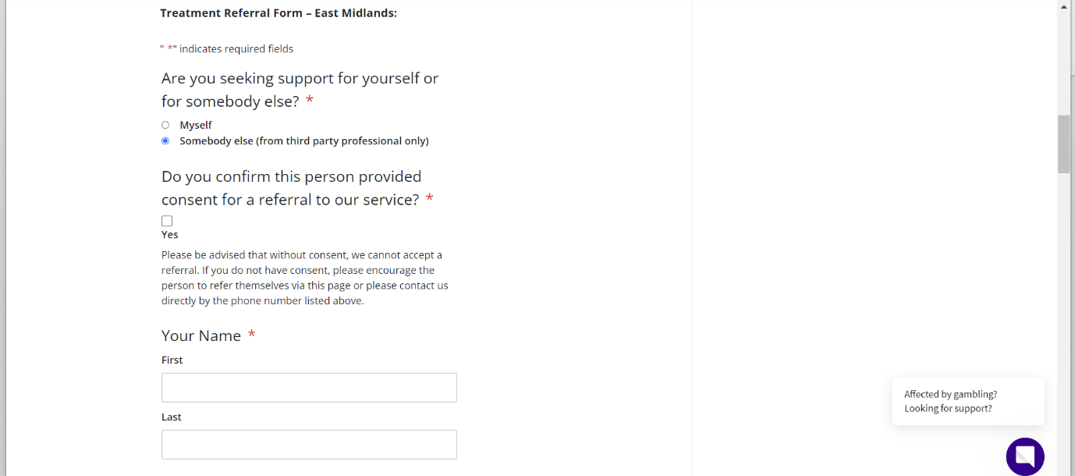

* Fill in the form provided, making sure you tick that you have consent of the individual who has been identified with gambling harms.
* Do make sure one form of contact is listed so we can contact the person affected.
* Once submitted, a member of our team will be in contact with them shortly.

